Summary biology unit 3: organs & cells
  - Big test, Monday 4th of February
Paragraph 3.1: Organs
All organisms are made up of organs, because if they wouldn’t have organisms, they wouldn’t show all the seven live-progresses, and in that case it isn’t an organism.
A torso or trunk is what we call the part of the body without legs, arms or head. It can also refer to a model of the human torso, with or without head.
The torso has two parts, separated by the diaphragm; the abdominal cavity and the thoracic cavity.
An organ is a part of an organism carrying out one or more functions.
ORGAN SYSTEMS
When organs work together to do a certain job we say they belong to an organ system. All the organ systems are:
- Digestive system: gullet, stomach, liver, intestines
- Skeletal system: e.g. skull, thigh bone, backbone, etc.
- Muscular system: e.g. biceps, thigh muscle, abdominal muscle etc.
- Circulatory system: heart, main vein, main artery, blood vessels
- Respiratory system: windpipe, lungs, bronchus
- Nervous system: brain, nerves
  - -look at last page for figure 1
Paragraph 3.2 Cells
All plants and animals are made up of cells. Cells seem to be flat, but they aren’t. In reality you can compare them with a box: there is something inside it. There are many different types of cells; they all look different because it has to its own job to do.
TISSUES
A tissue is a group of cells having the same shape and carrying out the same function. In some tissues extracellular material is found between the cells.
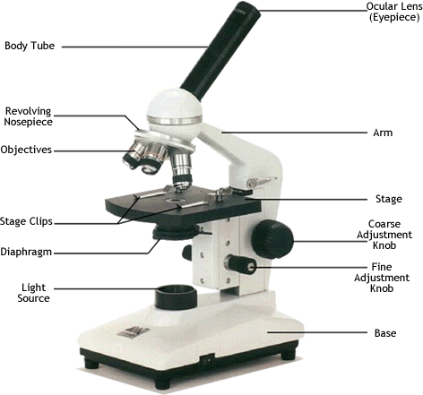
Paragraph 3.3: The microscope
-
Paragraph 3.4: Working with the microscope
Total magnification = eyepiece lens magnification x objective lens magnification

Paragraph 3.5: Plant cells
All cells have this:
Cytoplasm: a jelly-like fluid containing lots of chemicals. It fills the cell
Cell membrane: a thin flexible layer around the cell, which controls what enters and leaves
the cell
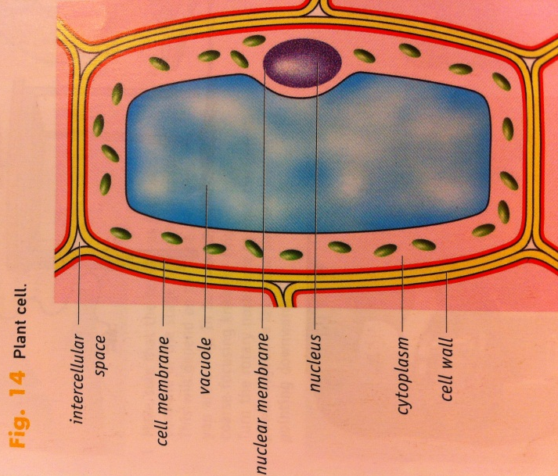
Nucleus: this controls what happens in the cell. The nucleus contains plasma as well and is surrounded by the nuclear membrane.
Plant cells have these parts as well, but they also have a cell wall which is a strong and rigid wall around the outside of the cell membrane. The cell wall is made of extracellular material so it doesn’t belong to the cell itself. The cell wall is made of cellulose which helps to give support to the cell.
The vacuole is like a sack in the middle of the cell that contains fluid.
The spaces filled with air between the different plant cells are called intercellular spaces.
PLASTIDS
The cytoplasm contains different kinds of grains called plastids. Chloroplasts, chromoplasts and leucoplasts are all closely related.
Chloroplasts (=bladgroenkorrels) make an organism green. They are able to absorb light energy which is needed during photosynthesis.
Chromoplasts (=chromoplasten) are enriched with pigments that give fruits and flowers their red, orange and yellow colours.
Leucoplasts are colourless plastids that store starch (=zetmeel).

Paragraph 3.6: Animal cells
